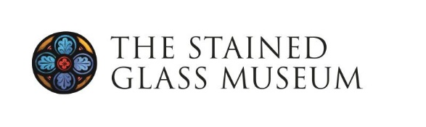
Student/Graduate Bursary Information – York Study Tour

19-22 April 2026
Application Deadline: Monday 2 February 2026, 5pm

About The Stained Glass Museum
The Stained Glass Museum is a small independent museum with a permanent gallery in Ely Cathedral. Its national significant collection of stained glass spans from the 13th to the 21st centuries. www.stainedglassmuseum.com

Supporting Students
The Stained Glass Museum wishes to encourage students and recent graduates with a particular interest in stained glass to take part in its events, in order to extend their knowledge and experience and strengthen their links with the Museum and wider stained glass community.

In 2026, we are delighted to invite applications for a student/graduate bursary place to enable a student/graduate to attend the Study Tour to be held in York, 19-22 April 2026. This bursary has been made available thanks to the generosity of individual Friends of the Stained Glass Museum.

Eligibility
You must be (a) currently registered in full or part-time study or (b) have completed a programme of study within the last two years to be eligible for the Study Tour Bursary. The bursary is aimed at those whose practical or academic studies are related (directly or indirectly) in some way to the art of stained glass, its history or conservation. Applicants will need to make sure that attending the Study Tour 19-22 April 2026 will not conflict with other work or academic commitments and, if necessary, gain permission to attend from their tutor/supervisor.

Details of the Bursary
The bursary covers a substantial proportion of the costs of attending the study tour including hotel accommodation, breakfast and dinner, but the successful applicant will need to fund and arrange their own travel to and from York, where we will be based, and lunches are not provided. A condition of accepting the grant is for the successful applicant to provide a short article for the Museum’s bi-annual Friends Newsletter describing the trip.
How to Apply
Applicants should apply using the simple form below, explaining how the 2026 Study Tour will help to develop their skills and knowledge, in relation to their programme of study and/or future ambitions (not more than 500 words).

Please submit a short CV together with your application.

The form and the CV should be sent to Emily Allen, Deputy Curator, by email emily@stainedglassmuseum.com or by post to the address below, by 5pm on Monday 2 February 2026.

Application Deadline
Monday 2 February 2026, 5pm

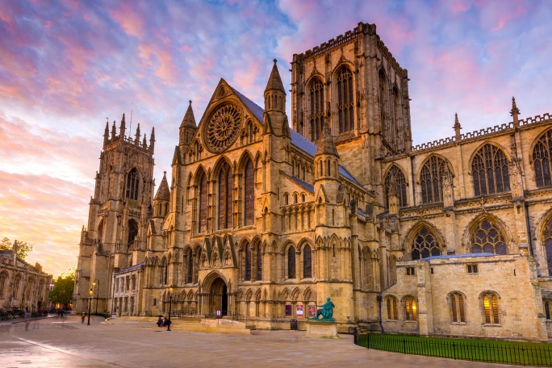
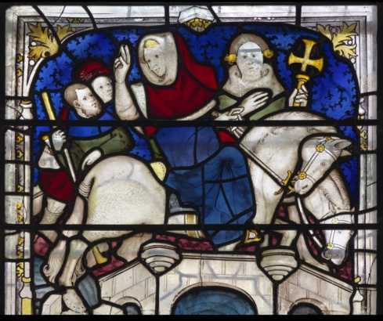
Programme
Our 2026 Study Tour will explore stained glass to be seen in and around the city of York on foot, as well as in the East Riding of Yorkshire, with a rare opportunity to be guided by resident experts. Whilst the medieval treasures of York Minster and the city’s parish churches are renowned, this visit will provide an opportunity to visit recently conserved windows at All Saints, North Street, York Minster, and St Denys, as well as the new Centre of Excellence for Heritage Craft Skills opened in 2025. We will visit two leading studios for the conservation of historic and creation of new stained glass – York Glaziers Trust and Barley Studios In addition, we will see windows by prominent York makers including Georgian glass-painter William Peckitt (1731-1795), 20th century glass artists Harry Stammers (1902-1969), Harry Harvey (1922-2011), and Helen Whittaker. By coach, we will visit less-well-known windows in the region by 19th century Belgian glass-painter Jean-Baptiste Capronnier, as well as Douglas Strachan (1875-1950) and Alf Fisher.
Fitness: Most days will be led on foot. Whilst we will plan to reduce walking distances between sites as much as we can, you will need to have reasonable fitness to walk across and around the city.
Dates
Registration will start at the earlier time of 1-2pm on Sunday 19 April 2026, followed by a couple of visits and an introductory talk before our group dinner. Site visits will continue all day on Monday and Tuesday with an earlier finish on Wednesday, by 2pm on Wednesday 22 April 2025.
Travel
York is easily accessible by train from various parts of the country with a direct train available from London via the East Coast main line and via the West, Midland and Cross County main lines.
Our accommodation at Middleton’s Hotel, York, is less than 1 mile from the train station and a 15-minute walk or short taxi-ride away. There is limited free parking at the hotel. Or, in the event the carpark is full, there are several public carparks a few minutes’ walk away, however, these are chargeable.
Accommodation and Dining
Accommodation packages include three nights’ accommodation and evening meals for Sunday, Monday and Tuesday nights. Extra nights on Saturday or Wednesday can be booked at an additional cost. On Sunday and Tuesday we will dine at the hotel, and on Monday evening we will have an exclusive dinner at the Merchant Adventurer’s Hall – an original timber-framed medieval guildhall and scheduled ancient monument which is home to The Company of Merchant Adventurers of the City of York, founded in the 14th century.
Guides
Guiding on site will be led by a group of experienced guides including Prof. Tim Ayers (Corpus Vitrearum), Keith Barley MBE (Barley Studios), Prof. Sarah Brown (University of York), and Dr Jasmine Allen (Director and Curator).
Workshop of John Thornton, ‘The Miracle of Ouse bridge’, St William Window, c.1414 ©York Minster

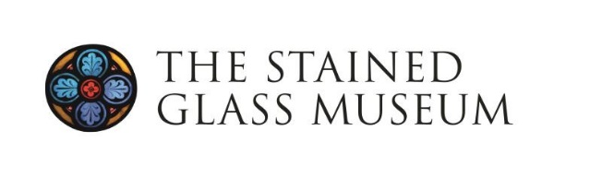
The Stained Glass Museum Study Weekend
Student Bursary Application Form
York, 19-22 April 2026
Contact Information
Name:
Email:
Address:
Contact No:

Details of your current (or most recent) Programme of Study
Title of your Course:
Institution/Place of Study:
Name of Supervisor/Tutor:
Course Start date: Course End date:

Application (no more than 500 words)

Please submit your application and C.V. by 5pm on Monday 2 February 2026

Emily Allen
Deputy Curator
The Stained Glass Museum
South Triforium
Ely Cathedral
Ely
CB7 4DL

Email: emily@stainedglassmuseum.com

